PART 1
- For each attribute of a relation, there is a set permitted values, called the______ of that attribute. answer{Domain}
- Domain
- Relation
- Set
- Schema
- Database ________. Which is the logical design of the database, and the database ________. Which is a snapshot of the data in the database at a given instant in time.
Answer{ Schema, instance}
- Instance, schema
- Relation, schema
- Relation, domain
- Schema, instance
- The tuples of relation one be of______ order. Answer {Any}
- Any
- Same
- Sorted
- Constant
- Which one of the following is a set of one or more attributes taken collectively to uniquely identify a record?
Answer(Super key)
- Candidate key
- Sub key
- Super key
- Foreign key
- if the ______ key from one relation is used as an attribute in that relation.
Answer(Primary)
- Candidate
- Super
- Primary
- Sub
- Tables in second normal from(2NF):
- Answer(Have all non-non key fields depend on the whole primary key)
- Eliminate all hidden dependencies
- Eliminate the possibility of a insertion anomalies
- Have a composite key
- Have all non-non key fields depend on the whole primary key
- Which forms simplifies and ensures that there is minimal data aggregates and repetitive groups:
- 1NF
- 2NF
- 3NF
- All of the mentioned

PART 2
- Define function dependency!
List the Armstrong indorns and state the below statement
{WX Y, XZ , ZWY} |= {XY}

- With reference to a sample relation of your own choosing, explain and discuss the
following relational model terminology, including its function and any related concepts.
A good diagram showing your sample relation is strongly suggested.
- Tuple
- Attribute
- Domain
- Degree
- Cardinality
Each item is equally weighted.
answer
Three marks per item with full marks only for covering all the following points. Tuple means row. Each row is uniquely identified by a primary key. Attribute means column. Each column must have a unique name within that table (relation) and can be isolated across tables by qualifying the column name with the table name (such as student.name) . The domain specifies what are acceptable data values within a column (and by implication the acceptable operations on that column’s data). The degree of a table is the width or number of columns and is part of the union compatibility criteria (the other one being that like - for - like columns in other results sets share comparable domains). The cardinality of a table is simply the depth or number of rows in the table. Good diagram gets bonus marks.

- The table shown below stores details of students and the overall grade each student obtained in different modules. The Primary Key is (StudentID, ModuleID).

StudentID | StudentName | ModuleID | ModuleName | Grade
S001 | Smith | M01 | Java | A
S001 | Smith | M02 | Databases | B
S002 | Ford | M01 | Java | B
(i) Which Normal Form does the above table violate and why?
(ii) Give an example of an update anomaly and an example of a delete anomaly that may occur if the table is left un - normalised. Explain the probl ems that are caused.
(iii) Show how you would n ormalise the table.
((((((answer)))))
(i) The table violates 2 nd Normal Form. because there are two partial dependencies: StudentID StudentName and ModuleID ModuleName .

(ii) Update anomaly: if a module is to be renamed, it is possible to mistype one of its instances, thus introducing an inconsistency .
Deletion anomaly: if students are deleted, modules will also be deleted, resulting in a loss of modules’ details .

(iii)
Student( StudentID , StudentName)
Module( ModuleID , ModuleName)
Results( StudentID *, ModuleID *, Grade)

- A company uses the table below to record details of st aff. Each staff has up to three qualifications:
StaffID | stafname | qualifications
S01 | Ibanga | BSc, MSc, PhD
S02 | Kumar | BSc, MSc
S03 | Grant | BSc, PhD
(i) Explain why this table is not in “First Normal Form” (1NF).
(ii) Show how this table can be transformed into 1NF tables.
answer
(i) The attribute “qualifications” is multi - valued on the PK, hence the table is not in 1NF.
(ii)Solutio n 1:
Students ( StaffID , StaffName, Qualification1, Qualification2, Qualification3)

Solution2:
Students ( StaffID , StaffName) (2 marks)
Qualifications ( StaffID *, Qualification ) (2 marks)
Alternatively, students can use a third table ( QualID , Qual ification)

- Refer to the ER model given i n Figure A1. Assume that : -

A Trainer x trained by no more than one Trainer.
A given horse competes in a particular race ridden by a particular jockey on a specific date and the position (ie 1 st ,2 nd etc) in which a horse finishes is recorded.

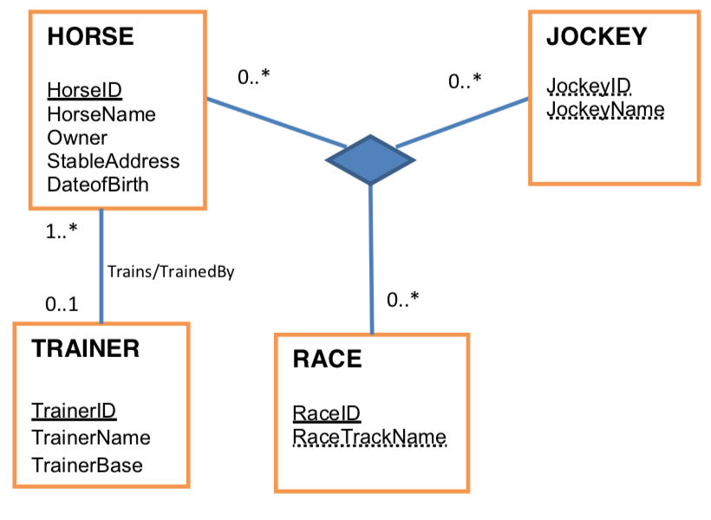
- In the context of database design give a precise definition of an Entity Type
answer
Entity type describes an object, a noun, a class any meaningful collection of objects of t he same type having the same properties/attributes
- Explain using examples from the ER model (figure A1) the difference between a ternary relationship and a binary relationship.
Answer
One mark each for identifying these relationships. Ternary relationships have three participating entity types whereas binary have two. Example : results and trains respectively. An example will show diagrammatically examples of instances of horseID , jockeyID , RaceID all participating in the same relationship. Binary relationship instances have a set of instances that relate a horse to a particular trainer and a trainer related to many horses. Some instances of a horse may not have a (current) trainer.
T he accuracy of the cardinality and participation is important in both cases.
- explain how you would modify the ER model given in Figure A1 in order to resolve many to many relationships.
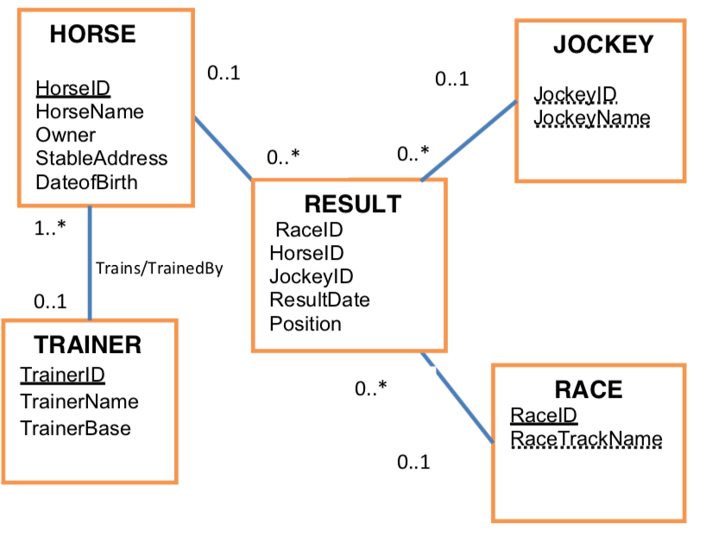
- Explain how you would translate your modified ER model (in part d) a s a set of Tables, giving table names, column names and an indication of primary and foreign keys.
answer
Many to many relationships automatically introduce an associative entity that maps directly to a new table with a composite key consisting of fields that exist in the original tables forming the relation ship. Hence the ternary relationship would be transformed into a table with a composite key comprising of the three identifiers from the three entity types forming the relationship. One to Many relationships map to two tables generally although technically this usually depends on the participation constraint on the one side.

Result Table (note italics/underlined = Foreign Key /bold = Primary Key.
HorseID.JockeyID, ResultDate , RaceID , Position

Horse table
HorseID, horsename ,Owner, DateOfBirth, Sta bleAddress, TrainerID

Trainer table
TrainerID , TrainerName, TrainerBase…

Jockey table
jockeyID , jockeyName

PART 3

1.What does the NULL value mean?
The meaning of the former type of NULL is not applicable, whereas the meaning of the latter is unknown. The unknown category of NULL can be further classified into two cases. The first case arises when it is known that the attribute value exists but is missing—for instance, if the Height attribute of a person is listed as NULL. The second case arises when it is not known whether the attribute value exists—for example, if the Home_phone attribute of a person is NULL.
2.Integrity constraints of relational model(only a list)
TYPES OF INTEGRITY CONSTRAINTS

Various types of integrity constraints are-
- Domain Integrity
- Entity Integrity Constraint
- Referential Integrity Constraint
- Key Constraints

3.Definition of Functional Dependency
A functional dependency is a constraint between two sets of attributes from the database. Definition. A functional dependency, denoted by X → Y, between two sets of attributes X and Y that are subsets of R specifies a constraint on the possible tuples that can form a relation state r of R. The constraint is that, for any two tuples t1 and t2 in r that have t1[X] = t2[X], they must also have t1[Y] = t2[Y].

4.Union type or category in EER model
For example, suppose that we have three entity types: PERSON, BANK, and COMPANY. In a database for motor vehicle registration, an owner of a vehicle can be a person, a bank (holding a lien on a vehicle), or a company. We need to create a class (collection of entities) that includes entities of all three types to play the role of vehicle owner. A category (union type) OWNER that is a subclass of the UNION of the three entity sets of COMPANY, BANK, and PERSON can be created for this purpose. We display categories in an EER diagram as shown in Figure 8.8. The superclasses COMPANY, BANK, and PERSON are connected to the circle with the ∪ symbol, which stands for the set union operation.

5.Attributes in ER model

8.Mapping of Binary 1:1 Relationship Types
For each binary 1:1 relationship type R in the ER schema, identify the relations S and T that correspond to
the entity types participating in R. There are three possible approaches: (1) the foreign key approach, (2) the merged relationship approach, and (3) the crossreference or relationship relation approach. The first approach is the most useful and should be followed unless special conditions exist, as we discuss below.

PART 4

- Context of database design give a precise definition of an Entity Type.
Entity type describes an object, a noun, a class any meaningful collection of objects of the same type having the same properties/attributes

- Outline why an ER model assists in database design.
High level model useful for semantic extraction and conveyance of meaning about real world objects and how they are associated. ER model often assists in normalisation if the number of tables is large as it is relatively easy to transform an ER model to 2NF. Many Case tools translate ER models to relations so an ER model can be regarded as a blueprint for many automation tools in DB design.

- Explain using examples from the ER model (figure A1) the difference between a ternary relationship and a binary relationship.
Ternary relationships have three participating entity types whereas binary have two. Example : results and trains respectively. An example will show diagrammatically examples of instances of horseID,jockeyID,RaceID all participating in the same relationship. Binary relationship instances have a set of instances that relate a horse to a particular trainer and a trainer related to many horses. Some instances of a horse may not have a (current) trainer.

- State why many to many relationships need to be resolved into one to many relationships in an ER model .
The relational model derived from an ER model cannot accommodate many to many relationships only one to many and one to one relationships. This is because a many to many relationship hides attributes that would suggest the existence of an entity type instead of the relationship type.

- Explain how you would translate your modified ER model (in part d) as a set of Tables, giving table names, column names and an indication of primary and foreign keys.
Many to many relationships automatically introduce an associative entity that maps directly to a new table with a composite key consisting of fields that exist in the original tables forming the relationship. Hence the ternary relationship would be transformed into a table with a composite key comprising of the three identifiers from the three entity types forming the relationship. One to Many relationships map to two tables generally although technically this usually depends on the participation constraint on the one side.

- What is the purpose of the HAVING keyword? Use a HAVING clause in query 2 above to show how it can be used to limit the rows in the output :
HAVING qualifies a GROUP BY with a condition operating on the group/set

- Discuss the advantages of using stored procedures as a way of implementing database queries.
Stored procedures encapsulate frequently run segments of code written in SQL code. They support parameterisation and may include sections of SELECTS/INSERTS/UPDATE statements. The code can be the same but the results are different by using different parameters and conditional expressions (IF/THEN/ELSE etc) when the code is run. Key advantages are reuse of code; security; abstraction/hiding code; avoid SQL injection attacks; validation code close to database.

